Name: Mushtaque Ali Khaskheli

Assignment: PF Lab 7

Sec: H

Task 1.
Input
#include<iostream>
using namespace std;
int main()
{
int size;
cout<<"Enter a size of array: ";
cin>>size;

int a[size];
for( int i=0; i<size; i++)
{
cout<<"Enter value number "<<i+1<<" : ";
cin>>a[i];
}

cout<<"Numbers in reverse order are: "<<endl;
for(int i=size-1; i>=0 ; i--)
cout<<a[i]<<" ";

return 0;
}
OUTPUT
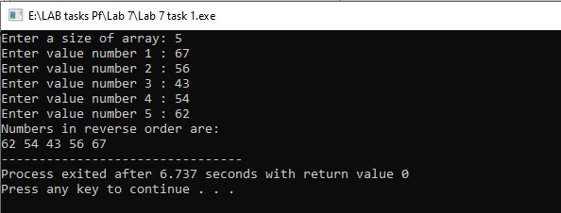
TASK 2.
Input
#include<iostream>
using namespace std;
int main()
{
int size, sum=0;
cout<<"Enter a size of array: ";
cin>>size;

int a[size];
for( int i=0; i<size; i++)
{
cout<<"Enter value number "<<i+1<<" : ";
cin>>a[i];
}
for(int i=0; i<size ; i++)
sum+=a[i];
cout<<"\nThe sum of given numbers is "<<sum<<endl;
return 0;
}

OUTPUT
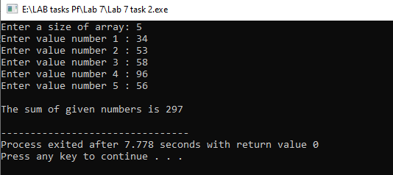

TASK 3.
INPUT
#include<iostream>
using namespace std;
int main()
{
int sum=0;
int average[10]={5,10,15,20,25,30,35,40,45,50};

cout<<"The values of the array are: ";
for(int i=0; i<10; i++)
cout<<average[i]<<" ";

cout<<endl;
for(int i=0; i<10 ; i++)
sum+=average[i];

cout<<"\nThe average is "<<sum/10<<endl;

return 0;
}

OUTPUT
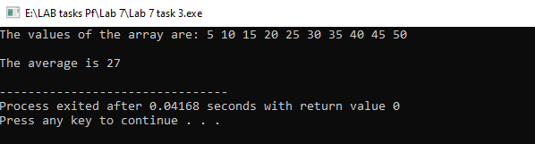
TASK 4
INPUT
#include<iostream>
using namespace std;
int main()
{
int num[5]={19,86,32,43,45}, n[5];
cout<<"The elements of first array are: \n";

for(int i=0; i<5; i++)
cout<<num[i]<<" ";

cout<<endl<<endl;
cout<<"The elements of second array are: \n";

for(int i=0; i<5; i++)
{
n[i]=num[i];
cout<<n[i]<<" ";
}

return 0;
}
OUTPUT
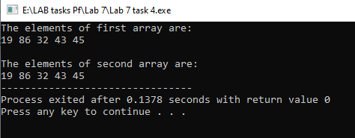

TASK 5
INPUT
#include<iostream>
using namespace std;
int main()
{
int size;
cout<<"Enter a size of array: ";
cin>>size;

int a[size];
for( int i=0; i<size; i++)
{
cout<<"Enter value number "<<i+1<<" : ";
cin>>a[i];
}

cout<<"The even numbers are: \n";
for(int i=0; i<size ; i++)
{
if(a[i]%2==0)
cout<<a[i]<<" ";
}

return 0;
}

OUTPUT
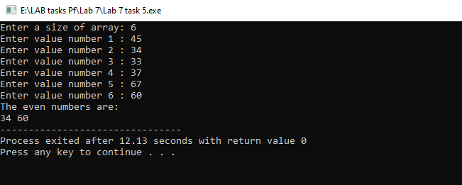

TASK 6.
INPUT
#include<iostream>
using namespace std;
int main()
{
int size;
cout<<"Enter a size of array: ";
cin>>size;
cout<<endl;

int a[size];
for( int i=0; i<size; i++)
{
cout<<"Enter value number "<<i+1<<" : ";
cin>>a[i];
}

cout<<"The values on the odd indices are: \n";
for(int i=0; i<size; i++)
{
if(i%2!=0)
cout<<a[i]<<" ";
}

return 0;
}
OUTPUT
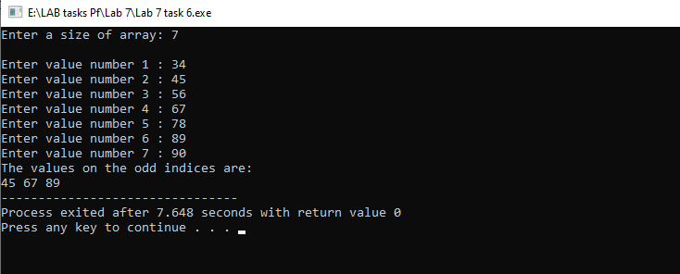

Task 7.
Input

#include<iostream>
using namespace std;
int main()
{
int size;
cout<<"Enter a size of array: ";
cin>>size;

int a[size], b[size]; // array1 and array 2
for( int i=0; i<size; i++)
{
cout<<"Enter value number "<<i+1<<" : ";
cin>>a[i];
}

cout<<"The elements of first array are: \n";
for(int i=0; i<size; i++)
cout<<a[i]<<" ";

cout<<endl<<endl;
cout<<"The elements of second array are: \n";
for(int i=size-1; i>=0; i--)
{
b[i]=a[i];
cout<<b[i]<<" ";
}

return 0;
}
Output
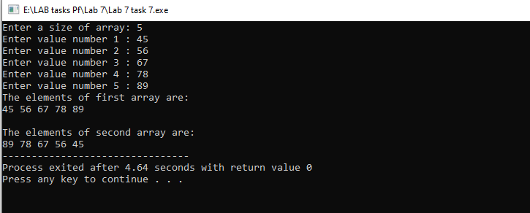
Task 8.
Input
#include<iostream>
using namespace std;
int main()
{
int arr1[5]={19,86,32,43,45}, arr2[5]={23,34,23,12,15},sum[5];
cout<<"The elements of first array are: \n";

for(int i=0; i<5; i++)
cout<<arr1[i]<<" ";

cout<<endl<<endl;
cout<<"The elements of second array are: \n";

for(int i=0; i<5; i++)
cout<<arr2[i]<<" ";

for(int i=0; i<5;i++)
sum[i]=arr1[i]+arr2[i];

cout<<endl<<endl;
cout<<"The sum of both arrays: \n";
for(int i=0; i<5; i++)
cout<<sum[i]<<" ";

return 0;
}

Output
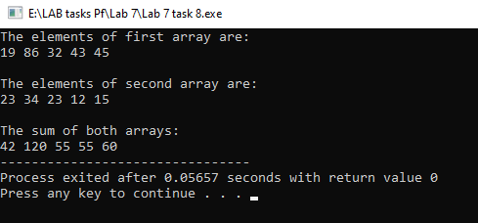

Task 9
Input
#include<iostream>
using namespace std;
int main()
{
int N=5, M=6; // any integers
int arr1[N]={19,86,32,43,45}, arr2[M]={23,34,23,12,15,20},arr3[N+M];
cout<<"The values of first array are: \n";

for(int i=0; i<N; i++)
cout<<arr1[i]<<" ";

cout<<endl<<endl;
cout<<"The values of second array are: \n";

for(int i=0; i<M; i++)
cout<<arr2[i]<<" ";

for( int i=0; i<N;i++)
arr3[i]=arr1[i];

for( int i=0; i<M;i++)
arr3[5+i]=arr2[i];

cout<<endl<<endl;
cout<<"The values of third array are: \n";
for(int i=0; i<N+M; i++)
cout<<arr3[i]<<" ";

return 0;
}

return 0;
}

Output
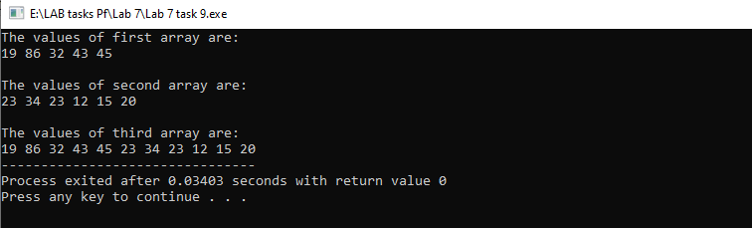

Task 10
Input
#include <iostream>
using namespace std;
int main ()
{
int size;
cout<<"input the number of students for which records are to be entered: ";
cin>>size;

int aPF[size],aMath[size],aEnglish[size],aPS[size],Totalmarks[size];
string aName[size];
float percentage[size];
char grade[size];

cout<<"Enter the names of all students:\n";
for(int i=0; i<size; i++)
cin>>aName[i];

for(int i=0; i<size; i++)
{
cout<<"Enter marks of Programing of "<<aName[i]<<" : ";
cin>>aPF[i];
}

cout<<endl;
for(int i=0; i<size; i++)
{
cout<<"Enter marks of Math of "<<aName[i]<<" : ";
cin>>aMath[i];
}

cout<<endl;
for(int i=0; i<size; i++)
{
cout<<"Enter marks of English of "<<aName[i]<<" : ";
cin>>aEnglish[i];
}

cout<<endl;
for(int i=0; i<size; i++)
{
cout<<"Enter marks of PS of "<<aName[i]<<" : ";
cin>>aPS[i];

}

for(int i=0; i<size; i++)
Totalmarks[i]=aPF[i]+aMath[i]+aEnglish[i]+aPS[i];
cout<<endl;

for(int i=0; i<size; i++)
percentage[i]=Totalmarks[i]*100.0/400;

cout<<endl;
for(int i=0; i<size; i++)
{
if(percentage[i]>=80 &&percentage[i]<=100)
grade[i]='A';

else if(percentage[i]>=70 &&percentage[i]<80)
grade[i]='B';

else if(percentage[i]>=60 &&percentage[i]<70)
grade[i]='C';

else if(percentage[i]<60)
grade[i]='F';

}

for(int i=0; i<=90; i++)
cout<<"=";

cout<<endl;
cout<<"Name\tProgramming Math English P.S Total Obtained Percentage Grade\n";

for(int i=0; i<=90; i++)
cout<<"=";
cout<<endl;

for(int i=0; i<size; i++)
cout<<aName[i]<<" "<<aPF[i]<<"\t\t "<<aMath[i]<<"\t "<<aEnglish[i]<<"\t "<<aPS[i]<<"\t\t "<<Totalmarks[i]<<"\t\t"<<percentage[i]<<"\t "<<grade[i]<<"\n";

for(int i=0; i<=90; i++)
cout<<"=";

return 0;
}

OUTPUT
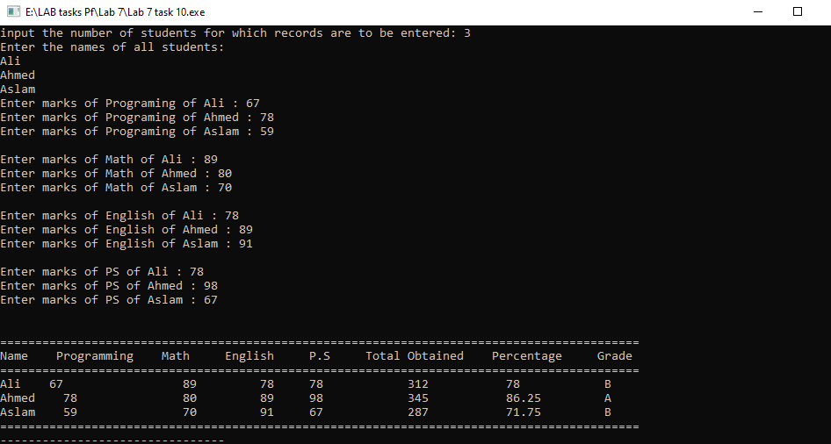

Task 11
Input
#include <iostream>
using namespace std;
int main ()
{
int size, smallest;
cout<<"Enter size if an array : ";
cin>>size;

cout<<"Enter number "<<1<<" : ";
cin>>smallest;

int arr[size];
for(int i=1; i<size; i++)
{
cout<<"Enter number "<<i+1<<" : ";
cin>>arr[i];

if(arr[i]<smallest)
smallest=arr[i];

}
cout<<endl<<"The smallest number is "<<smallest;

return 0;
}
OUTPUT
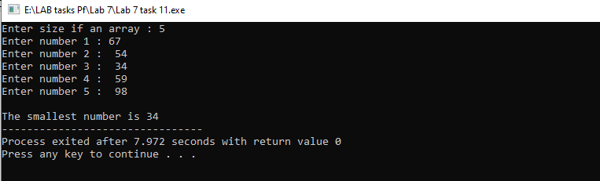

Task 12
Input
#include <iostream>
using namespace std;
int main ()
{
int size, largest;
cout<<"Enter size of an array : ";
cin>>size;

cout<<"Enter number "<<1<<" : ";
cin>>largest;

int arr[size];
for(int i=1; i<size; i++)
{
cout<<"Enter number "<<i+1<<" : ";
cin>>arr[i];

if(arr[i]>largest)
largest=arr[i];

}
cout<<endl<<"The largest number is "<<largest;

return 0;
}
OUTPUT
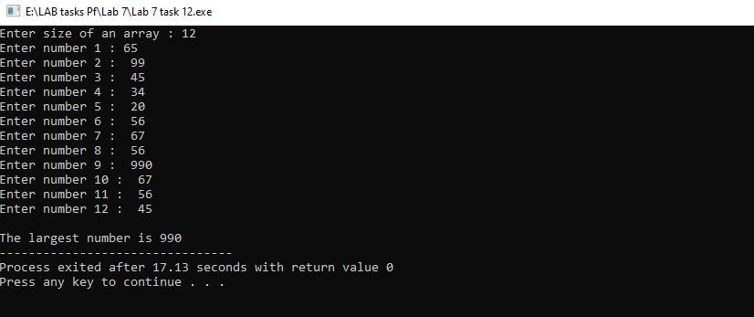

Task 13
Input
#include<iostream>
using namespace std;
int main()
{
int size, search, temp;
bool found=false;
cout<<"Enter a size of array: ";
cin>>size;

int arr[size];
for( int i=0; i<size; i++)
{
cout<<"Enter value number "<<i+1<<" : ";
cin>>arr[i];
}

cout<<"Enter the value you want to search from this array : ";
cin>>search;

for(int i=0; i<size ; i++)
{

if(arr[i]==search)
{
temp=i;
found=true;
break;
}

}

if(found)
cout<<search<<" is present in the array at index "<<temp;
else
cout<<search<<" is not present in the array...\n\n";

return 0;
}

OUTPUT
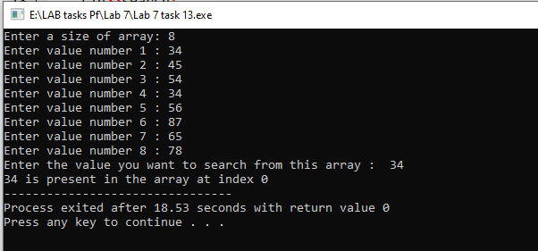
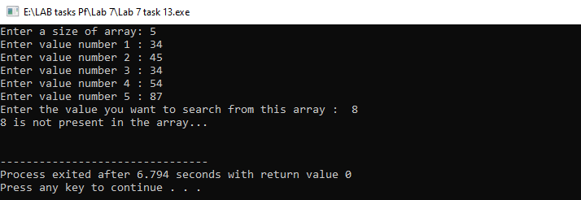

The End

